Screenshot 1: Inventory ping
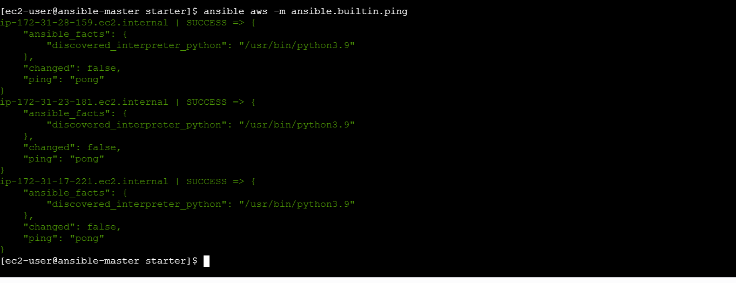
Screenshot 2: Successful playbook recap
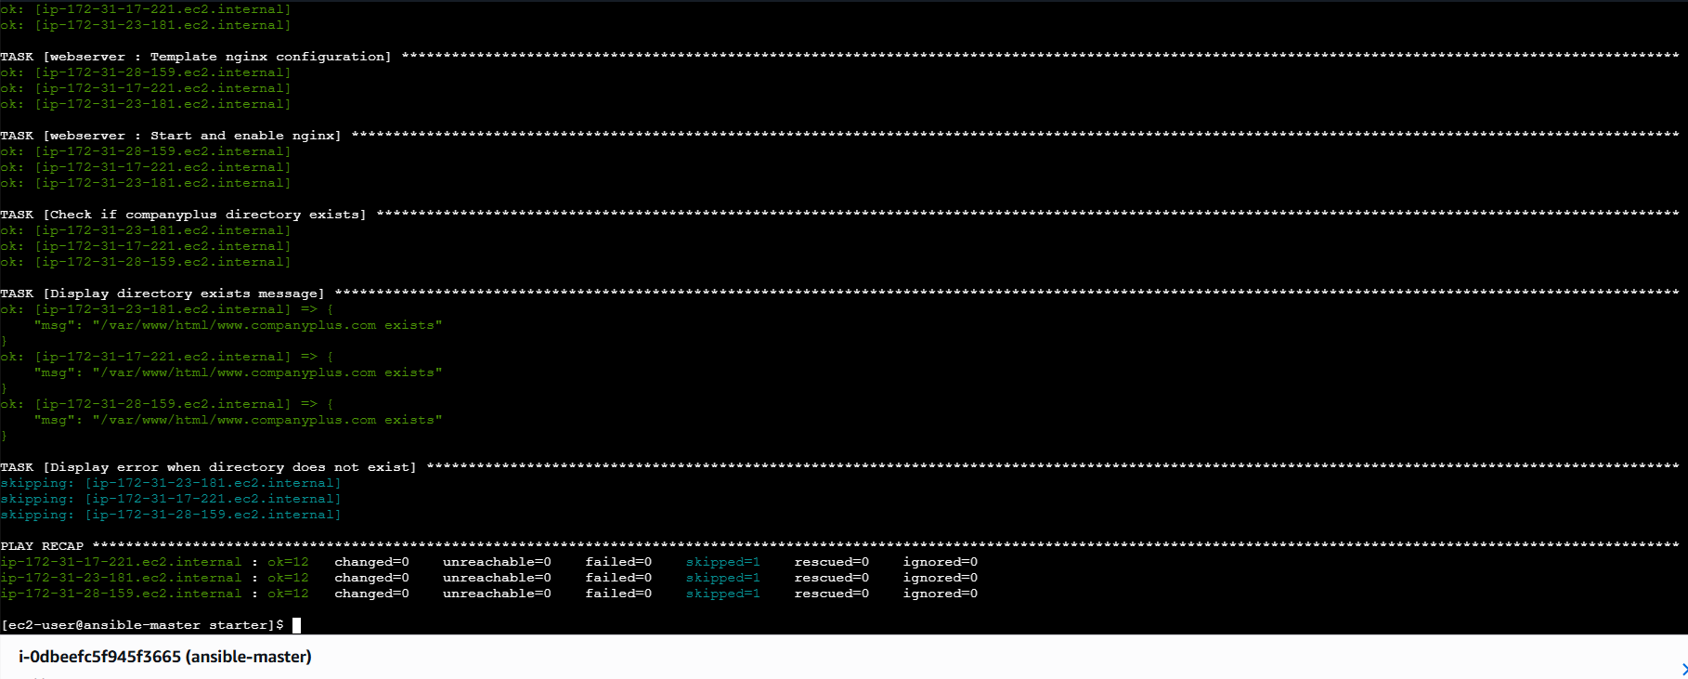
Screenshot 3: Nginx active
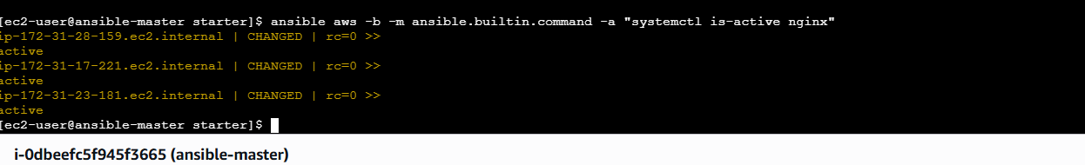
Screenshot 4: Ports 80 and 443
